**Software Design Document**

**SmartClass: AI-Based Learning Management & Assessment System**



**Submitted by:**

**Sawera Saeed (F22BINFT1M01144)**

**BSIT (3M)**

**Submitted to:**

**Dr. Mustafa Hameed**

**Department of Information Technology**

**Faculty of Computing**

**The Islamia University of Bahawalpur**

**Summery**

This Software Design Document (SDD) describes the design of the SmartClass web application. The purpose of this document is to explain the system design, main components, and architecture used to develop the SmartClass system. This document is prepared based on the requirements defined in the Software Requirement Specification (SRS).

SmartClass is an online learning management system developed to support students, teachers, and administrators. The system provides features such as user authentication, course management, quizzes, assignments, and profile management. An important part of the system is the use of Artificial Intelligence (AI) to automatically generate quiz questions and assignment questions, and to perform auto-grading of quizzes. These features help reduce manual effort and improve learning efficiency.

The system is designed using a modular and scalable approach. The frontend is developed using React, which provides a responsive and user-friendly interface. The backend is developed using Django, which handles business logic, authentication, authorization, and API services. The system follows a REST-based architecture, allowing smooth communication between frontend and backend.

Security and performance are key design considerations. The system uses JWT-based authentication, role-based access control, and secure password handling. The database is implemented using PostgreSQL to ensure data integrity and reliability. Cloud storage is used for storing profile images and uploaded files.

Overall, this document presents the design decisions, system architecture, and component-level details of the SmartClass application. It serves as a reference for developers and stakeholders to understand how the system is structured and how different modules interact with each other.

**Table of Content**

Table of Content 3

1. Application Architecture 3

1.1. MVC Architecture Overview 3

Figure: 4

Figure 1.1: Application Architecture of SmartClass System 4

1.2. Models 4

Figure: 5

1.3. Views 5

1.4. Controllers 6

Authentication Controller 6

Course Controller 9

Quiz Controller 10

Assignment Controller 12

Admin Controller 12

1.5. APIs 13

1.6. External APIs and Libraries 14

1.7. Coding Conventions 14

2. Data Model Schema 15

2.1 Data Model Entities Description 15

1. User Entity 15

2. Profile Entity 16

3. Teacher Profile Entity 17

4. Student Profile Entity 18

5. Quiz Entity 18

6. Question Entity 19

7. Assignment Entity 19

8. Submission Entity 20

9. Result / Auto-Grading Entity 21

Entity Relationship Diagram (ER Diagram) 21

3. User Interface 22

1. Overall Design Philosophy 22

2. List of Screens / Pages 23

3. Screen Details and Controls 23

3.1 Splash Screen 23

3.2 Onboarding Screens 24

3.3 Login Screen 25

3.4 Registration Screen 26

3.5 Forgot Password Screen 27

3.6 Reset Password Screen 28

3.7 Dashboard Screen (Student / Teacher) 29

3.8 Profile Screen 30

3.9 Quiz Screen 31

3.10 Assignment Screen 32

3.11 Result / Grades Screen 33

3.12 Navigation Flow Diagram 34

1. **Application Architecture**

The SmartClass system follows a **Model–View–Controller (MVC)** architecture pattern. This architecture helps to separate the application logic, user interface, and data handling, which makes the system easier to understand, maintain, and scale.

### **1.1. MVC Architecture Overview**

* **Model**: Handles database structure and data logic
* **View**: Handles user interface (Frontend)
* **Controller**: Handles requests, responses, and business logic

In SmartClass, the **backend (Django)** mainly represents the **Model and Controller**, while the **frontend (React)** works as the **View** layer.

### **Figure:**

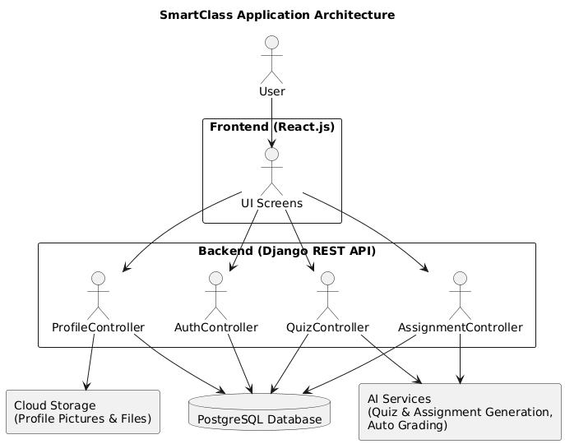

Figure 1.1: Application Architecture of SmartClass System

### **1.2. Models**

Models are responsible for storing and managing data in the database. The following main models are proposed in the system:

* User
* StudentProfile
* TeacherProfile
* Course
* Quiz
* Assignment
* Question
* Submission
* Result
* RefreshToken

### **Figure:**

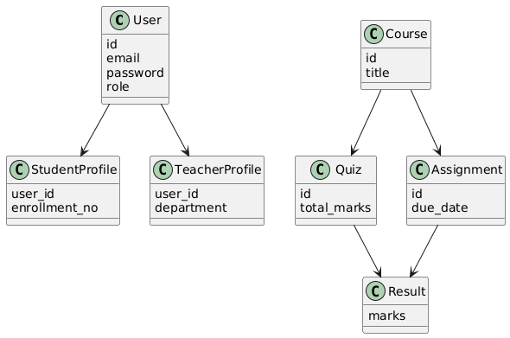 Figure 1.2: Class diagram of the online learning system.

### **1.3. Views**

Views represent the frontend user interface. These views are developed using **React.js** and include:

* Login and Registration Screens
* Student Dashboard
* Teacher Dashboard
* Quiz and Assignment Screens
* Profile Management Screens

### **1.4. Controllers**

Controllers handle all system logic. They receive requests from the frontend, process them, interact with models, and return responses.

Below are the list of main controllers and their functions:

#### **Authentication Controller**

* Register new users
* Login users
* Email verification
* Password reset
* JWT token generation and validation

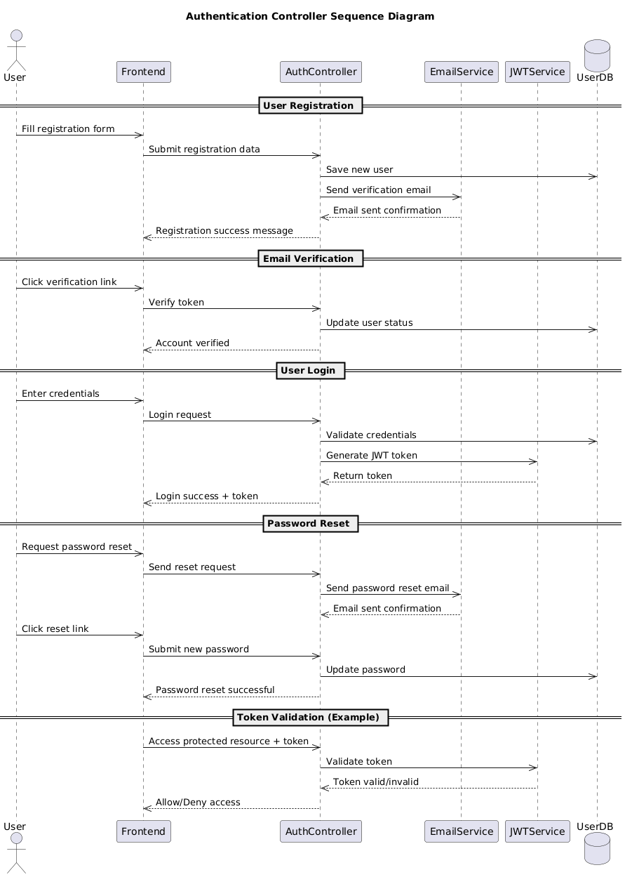Figure 1.3: Authentication Controller Sequence Diagram

**Profile Controller**

* Get user profile
* Update profile information
* Upload profile picture
* Delete profile picture

**Figure:**

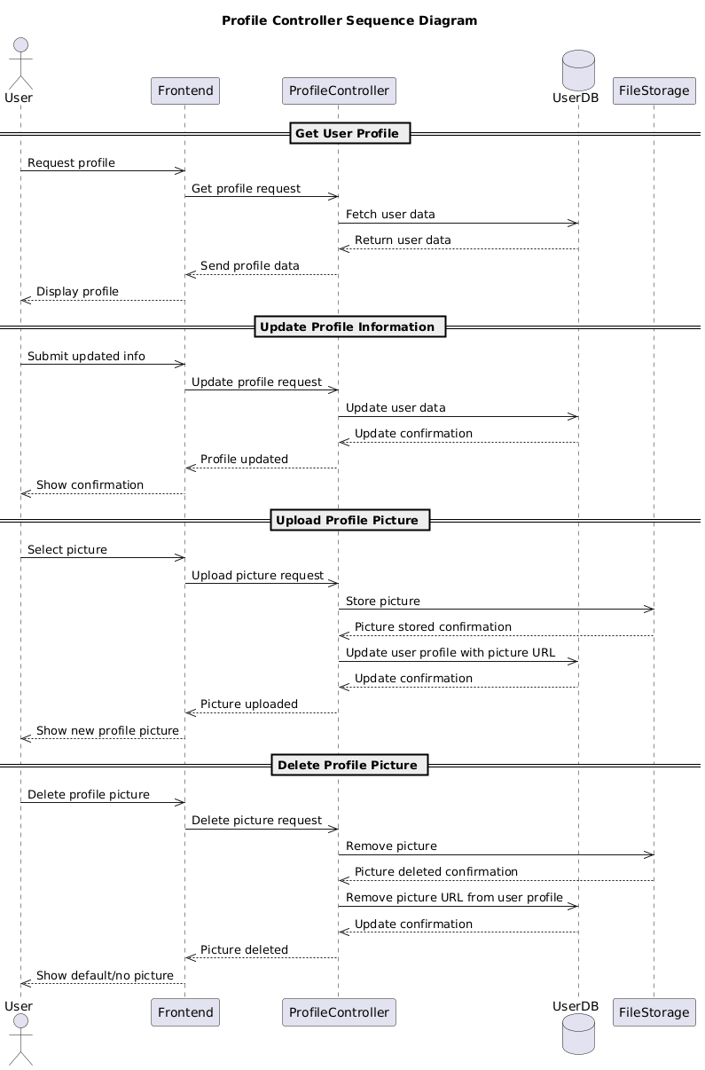 Figure 1.4: Profile Controller Sequence Diagram

**Course Controller**

* Create courses
* Assign teachers to courses
* Enroll students

**Figure:**

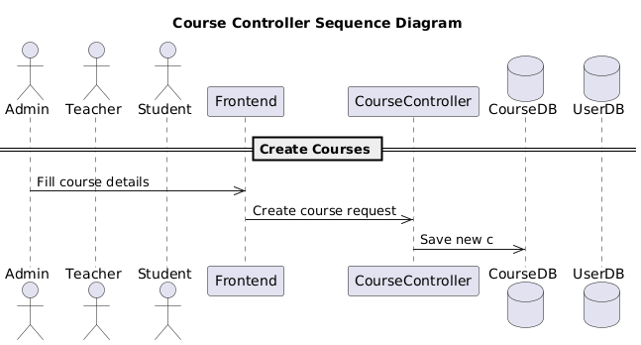 Figure 1.5: Course Controller Sequence Diagram

#### **Quiz Controller**

* Create quizzes
* Generate quiz questions using AI
* Auto-grade quizzes
* Store quiz results

**Figure:**

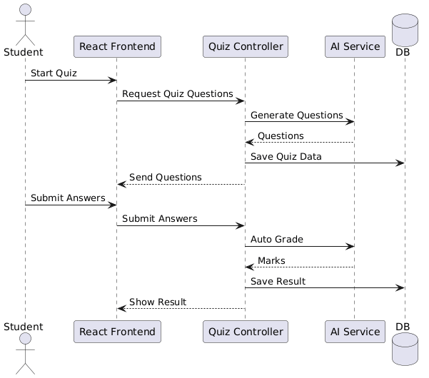Figure 1.6: Sequence diagram for quiz flow in the online learning system

#### **Assignment Controller**

* Generate assignment questions using AI
* Accept student submissions
* Auto-evaluate assignments

**Figure:**

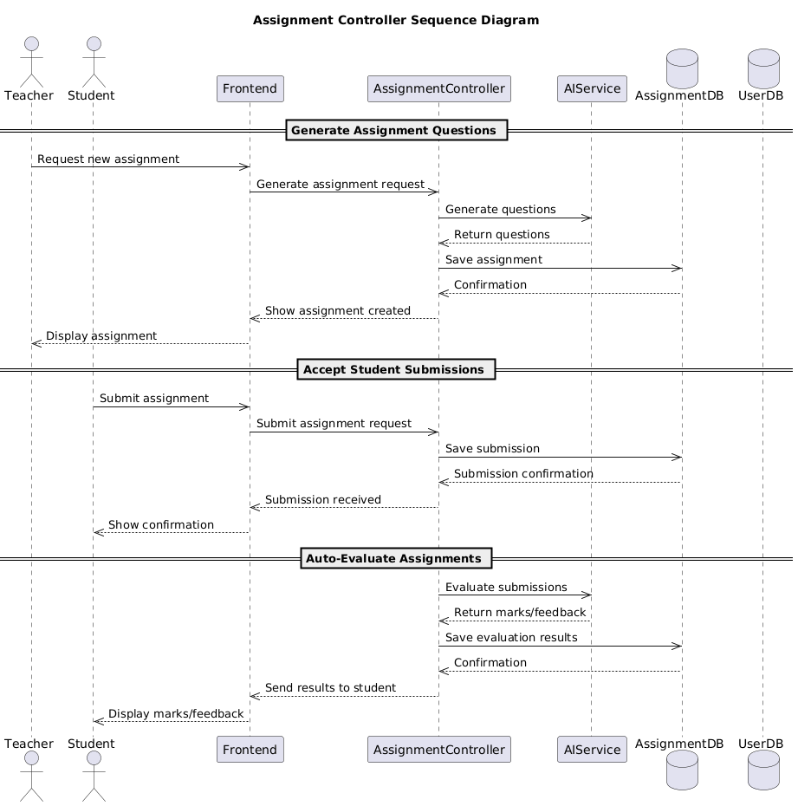

Figure 1.7: Assignment Controller Sequence Diagram

#### **Admin Controller**

* Manage users
* Manage roles and permissions
* Monitor system activity

**Figure:**

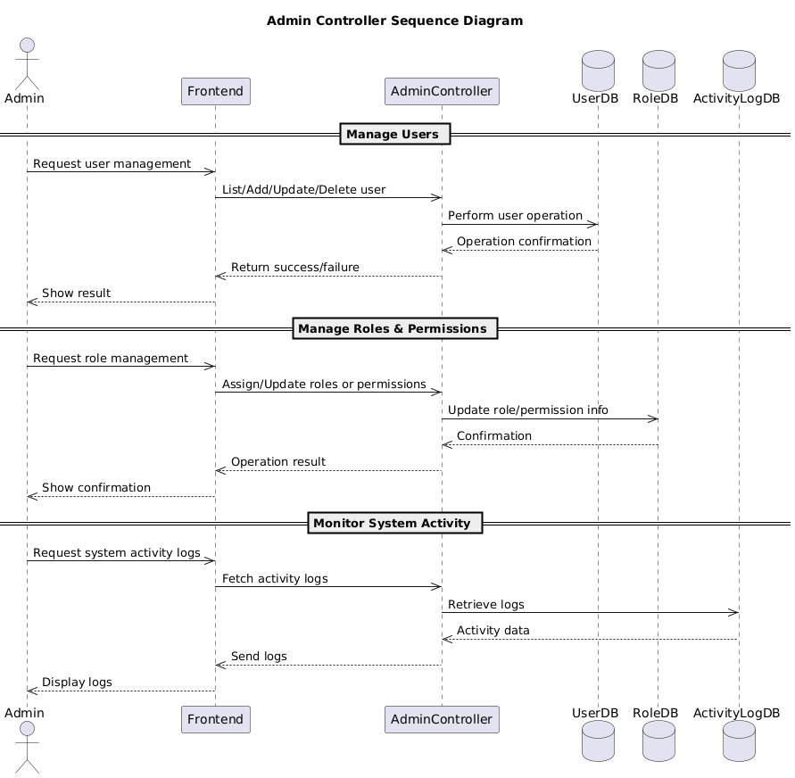

Figure 1.8: Admin Controller Sequence Diagram

### **1.5. APIs**

The system uses **RESTful APIs** for communication between frontend and backend.

Examples of APIs:

* /api/v1/auth/login/
* /api/v1/auth/register/
* /api/v1/profile/
* /api/v1/quizzes/
* /api/v1/assignments/

All APIs use **JWT-based authentication** for secure access.

### **1.6. External APIs and Libraries**

The following external APIs and libraries are used in the system:

**JWT**  
 Used for authentication and authorization.

**AI API**  
 **Used for:**

Quiz question generation

Assignment question generation

**Auto-grading**

**Cloud Storage API**  
 Used to store profile pictures and uploaded files.

**Email Service API**  
 Used for account verification and password recovery.

## **1.7. Coding Conventions**

The following coding conventions are followed in the SmartClass system:

* Python follows **PEP-8 standards**
* Proper naming conventions for variables and functions
* Separate folders for apps (auth, profiles, courses)
* RESTful API naming standards
* Reusable and modular code structure
* Comments added for better understanding

1. **Data Model Schema**

The data model defines how information is stored, managed, and related inside the system.  
 SmartClass uses a **relational database (PostgreSQL)** where all entities are connected through primary and foreign keys.

The system is designed to support:

* User authentication
* Student and teacher profiles
* AI-based quiz and assignment generation
* Automatic grading
* Profile management

## **2.1 Data Model Entities Description**

The SmartClass system uses a relational database. Each entity represents a real-world object and is connected with other entities through relationships. The main entities of the system are User, Profile, Teacher Profile, Student Profile, Quiz, Question, Assignment, Submission, and Result.

### **1. User Entity**

The **User** entity stores authentication and authorization related information of all users in the system. Every user must register and log in before using the system.

**Attributes:**

* User ID (Primary Key)
* Email
* Password
* First Name
* Last Name
* Role (Admin, Teacher, Student)
* Is Active
* Date Created

**Working:**  
 The User entity is used for login, role-based access control, and security. Based on the role, users are allowed to access different features.

**Relationships:**

* One User has one Profile
* One User can create many Quizzes (Teacher)
* One User can create many Assignments (Teacher)
* One User can submit many Assignments (Student)

### **2. Profile Entity**

The **Profile** entity stores general profile information for users.

**Attributes:**

* Profile ID (Primary Key)
* User ID (Foreign Key)
* Bio
* Institution
* Profile Picture URL

**Working:**  
 This entity allows users to manage their personal information separately from authentication data.

**Relationships:**

* One Profile belongs to one User

### **3. Teacher Profile Entity**

The **Teacher Profile** entity stores teacher-specific information.

**Attributes:**

* Teacher Profile ID (Primary Key)
* User ID (Foreign Key)
* Subjects
* Experience
* Qualification

**Working:**  
 This entity is only created for users with the teacher role. It helps in managing academic data related to teachers.

**Relationships:**

* One Teacher Profile belongs to one User
* One Teacher can create many Quizzes
* One Teacher can create many Assignments

### **4. Student Profile Entity**

The **Student Profile** entity stores student-specific information.

**Attributes:**

* Student Profile ID (Primary Key)
* User ID (Foreign Key)
* Enrollment Number
* Class Level

**Working:**  
 This entity is only created for student users. It is used to track academic activities.

**Relationships:**

* One Student Profile belongs to one User
* One Student can attempt many Quizzes
* One Student can submit many Assignments

### **5. Quiz Entity**

The **Quiz** entity stores information about quizzes generated using AI.

**Attributes:**

* Quiz ID (Primary Key)
* Title
* Subject
* Created By (Teacher ID)
* Total Marks
* Created Date

**Working:**  
 Quizzes are generated with the help of AI services. Teachers can create quizzes and students can attempt them online.

**Relationships:**

* One Quiz is created by one Teacher
* One Quiz has many Questions

### **6. Question Entity**

The **Question** entity stores individual questions of quizzes and assignments.

**Attributes:**

* Question ID (Primary Key)
* Quiz ID (Foreign Key)
* Question Text
* Options
* Correct Answer
* Marks

**Working:**  
 Questions are generated automatically by AI and stored in the database for evaluation.

**Relationships:**

* Many Questions belong to one Quiz

### **7. Assignment Entity**

The **Assignment** entity stores assignment details created by teachers.

**Attributes:**

* Assignment ID (Primary Key)
* Title
* Description
* Created By (Teacher ID)
* Due Date

**Working:**  
 Assignments can be generated manually or using AI. Students submit assignments online.

**Relationships:**

* One Assignment is created by one Teacher
* One Assignment has many Submissions

### **8. Submission Entity**

The **Submission** entity stores student assignment submissions.

**Attributes:**

* Submission ID (Primary Key)
* Assignment ID (Foreign Key)
* Student ID (Foreign Key)
* Submitted File
* Submission Date

**Working:**  
 Students upload their assignments which are then processed for evaluation.

**Relationships:**

* One Submission belongs to one Assignment
* One Submission belongs to one Student

### **9. Result / Auto-Grading Entity**

The **Result** entity stores grading results generated by AI.

**Attributes:**

* Result ID (Primary Key)
* Submission ID (Foreign Key)
* Obtained Marks
* Feedback
* Graded Date

**Working:**  
 AI automatically checks quizzes and assignments and generates marks and feedback.

**Relationships:**

* One Result belongs to one Submission

### **Entity Relationship Diagram (ER Diagram)**

To explain the working of entities and their relationships, an ER diagram is provided. The ER diagram shows how users are connected with profiles, quizzes, assignments, and results.

**Figure:**

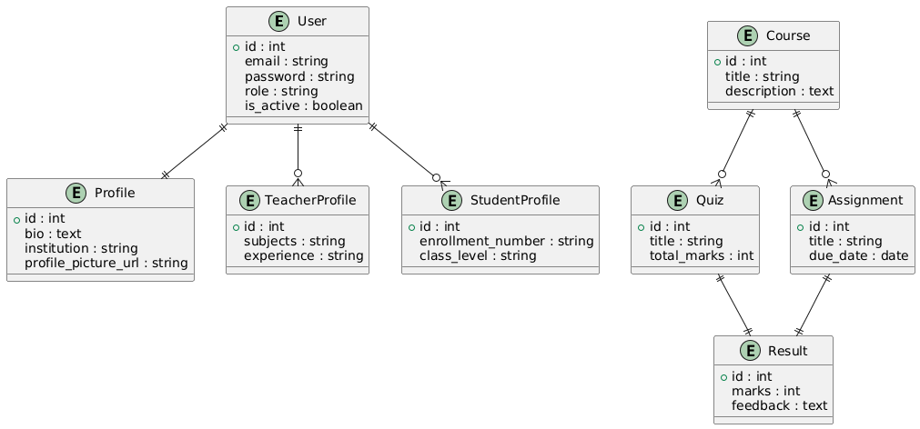Figure 2.1: ER Diagram of the SmartClass System

1. **User Interface**

## **1. Overall Design Philosophy**

The SmartClass application follows a simple, clean, and user-friendly design philosophy.  
 The main goal of the user interface is to make the system easy to understand and use for students, teachers, and administrators.

**Color Scheme:**  
 Light background with blue and white colors is used to give a professional and educational look.  
 Important buttons (Login, Submit, Save) use darker colors for visibility.

**Font Style:**  
 Simple and readable fonts such as Sans-Serif are used to ensure clarity on all devices.

**Design Niche:**  
 Modern web-based educational system with a clean dashboard layout.

Screen Constraints & Responsiveness:  
 The application is responsive, meaning it works properly on:

* Desktop computers
* Laptops
* Tablets
* Mobile phones

Layout automatically adjusts according to screen size.

## **2. List of Screens / Pages**

The following screens are included in the SmartClass system:

1. Splash Screen
2. Onboarding Screens
3. Login Screen
4. Registration Screen
5. Forgot Password Screen
6. Reset Password Screen
7. Student Dashboard
8. Teacher Dashboard
9. Profile Screen
10. Quiz Screen
11. Assignment Screen
12. Result / Grades Screen

## **3. Screen Details and Controls**

### **3.1 Splash Screen**

**Purpose:**  
 Displayed when the application starts. It checks whether the user is already logged in.

**Controls:**

* No user input
* Loading indicator

**Diagram:**

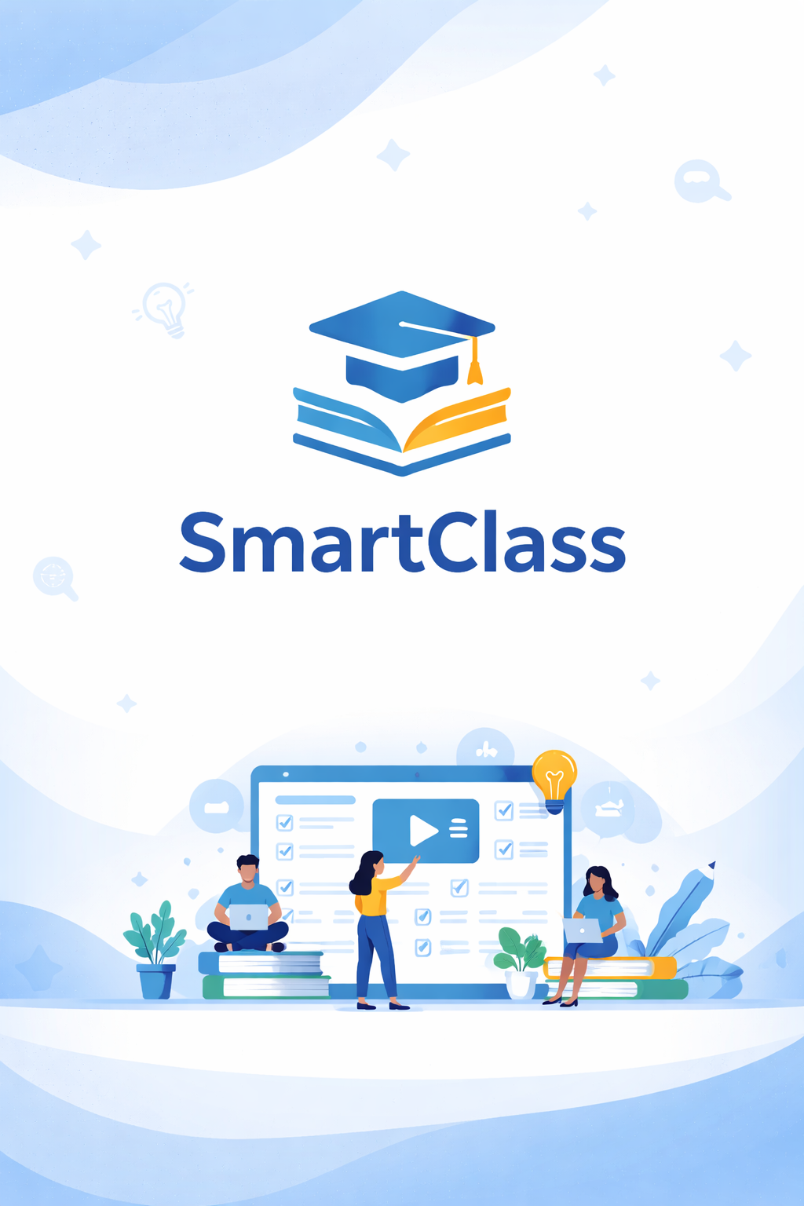

### **3.2 Onboarding Screens**

**Purpose:**  
 Shown to first-time users to explain application features.

**Controls:**

* Next Button
* Skip Button

**Diagram:**

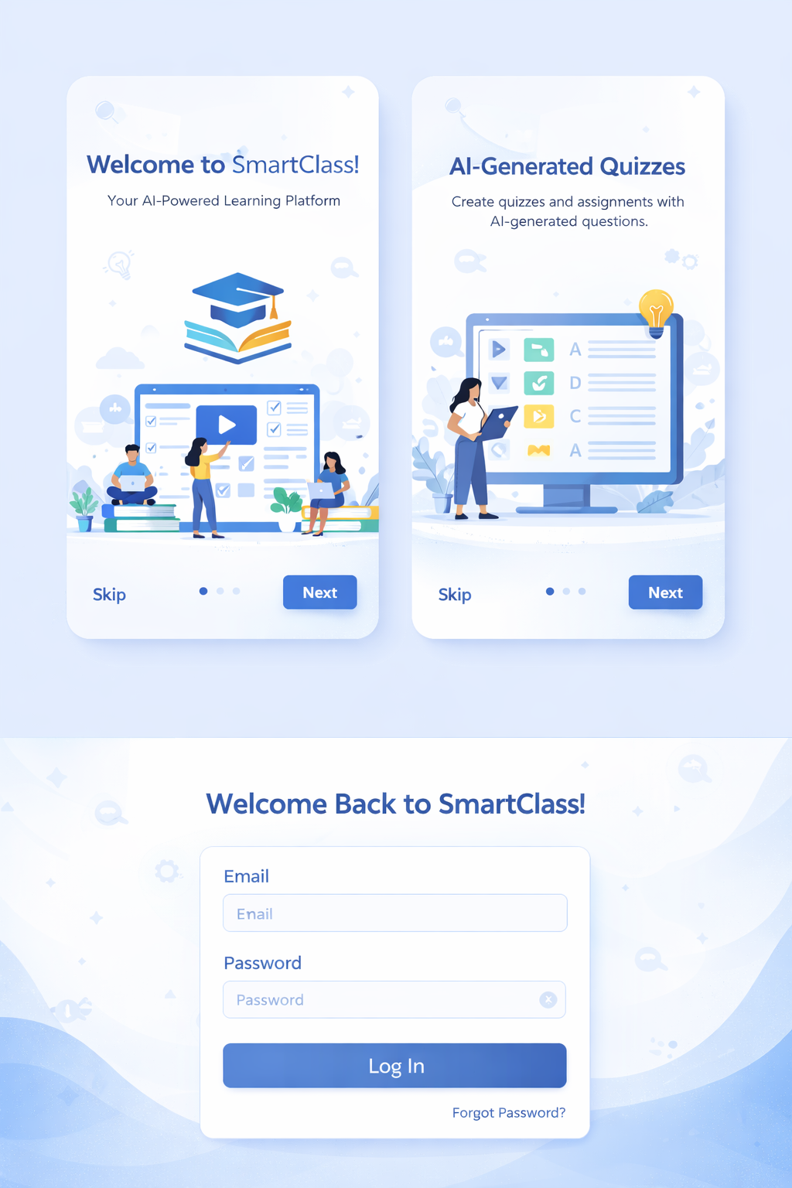

### **3.3 Login Screen**

**Purpose:**  
 Allows users to log into the system.

**Controls:**

* Textbox: Email
* Password Field
* Login Button
* Forgot Password Link

**Input Constraints:**

* Email must be in valid format
* Password cannot be empty

**Diagram:**



### **3.4 Registration Screen**

**Purpose:**  
 Allows new users to create an account.

**Controls:**

* Textbox: First Name
* Textbox: Last Name
* Textbox: Email
* Password Field
* Role Dropdown (Student / Teacher)
* Register Button

**Input Constraints:**

* Email must be unique
* Password minimum length required
* All required fields must be filled

**Diagram:**

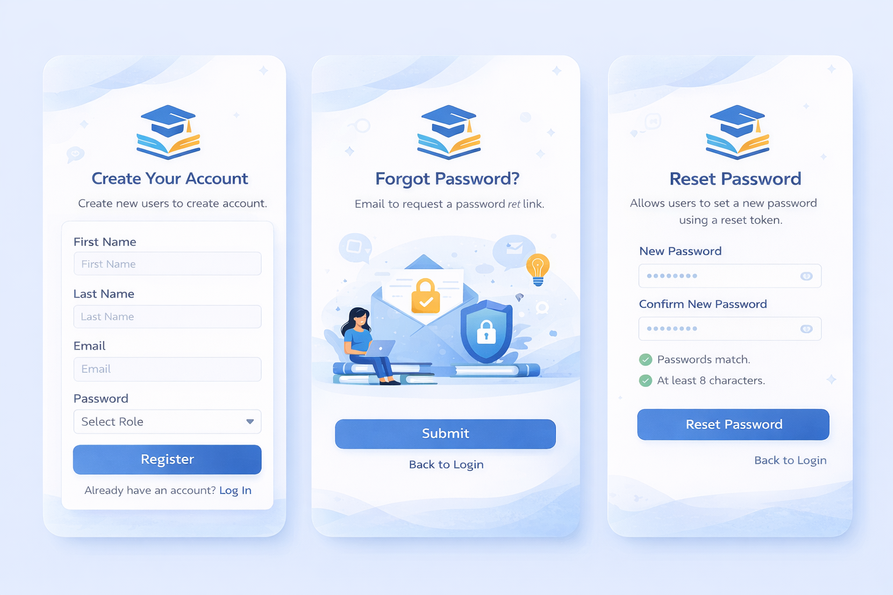

### **3.5 Forgot Password Screen**

**Purpose:**  
 Allows users to request a password reset link.

**Controls:**

* Textbox: Email
* Submit Button

**Input Constraints:**

* Valid registered email required

**Diagram:**



### **3.6 Reset Password Screen**

**Purpose:**  
 Allows users to set a new password using reset token.

**Controls:**

* Password Field
* Confirm Password Field
* Reset Button

**Input Constraints:**

* Passwords must match
* Password strength validation

**Diagram:**



### **3.7 Dashboard Screen (Student / Teacher)**

**Purpose:**  
 Main screen after login showing user-specific features.

**Controls:**

* Navigation Menu
* Buttons for Quizzes, Assignments, Profile, Logout

**Diagram:**

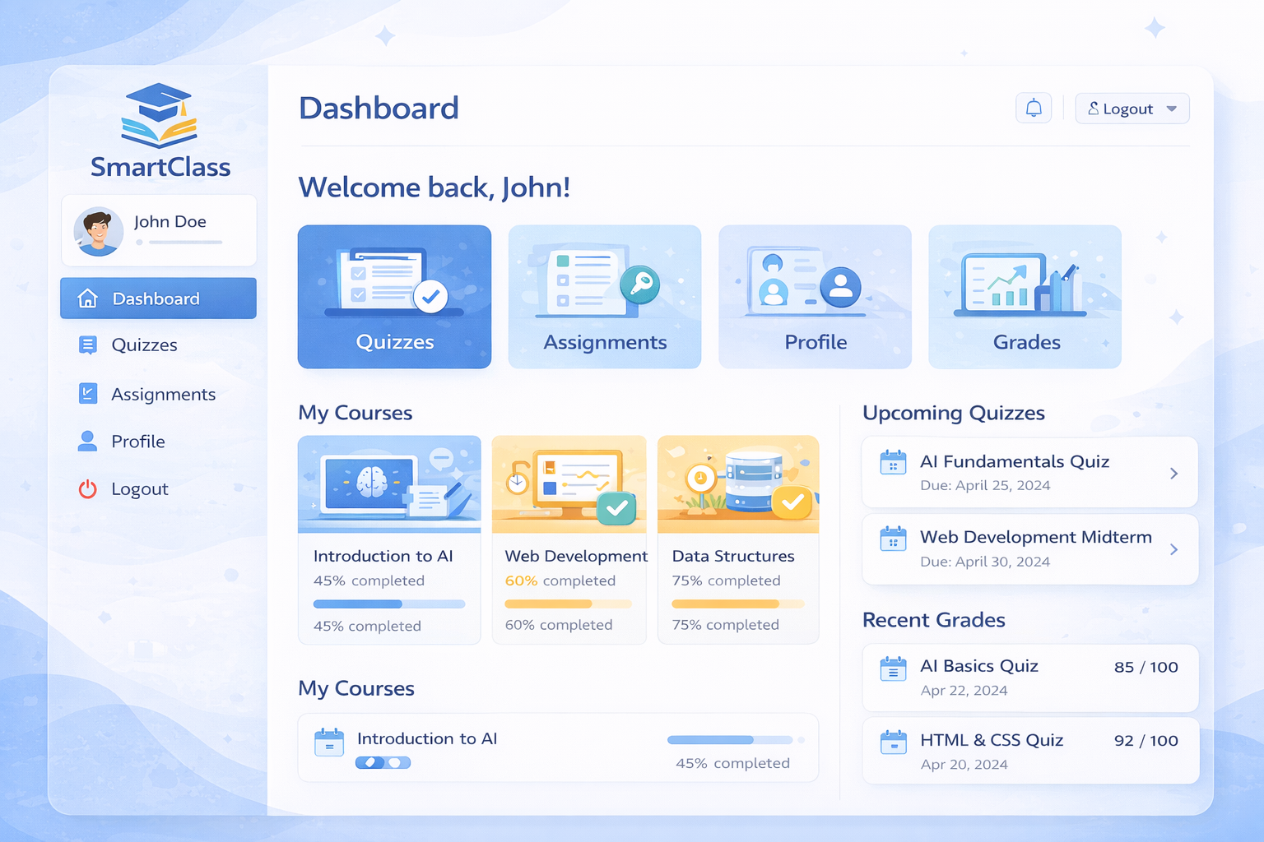

### **3.8 Profile Screen**

**Purpose:**  
 Displays and updates user profile information.

**Controls:**

* Textbox: Bio
* Textbox: Institution
* Upload Button: Profile Picture
* Save Button

**Input Constraints:**

* Image upload size limit
* Text length limits

**Diagram:**

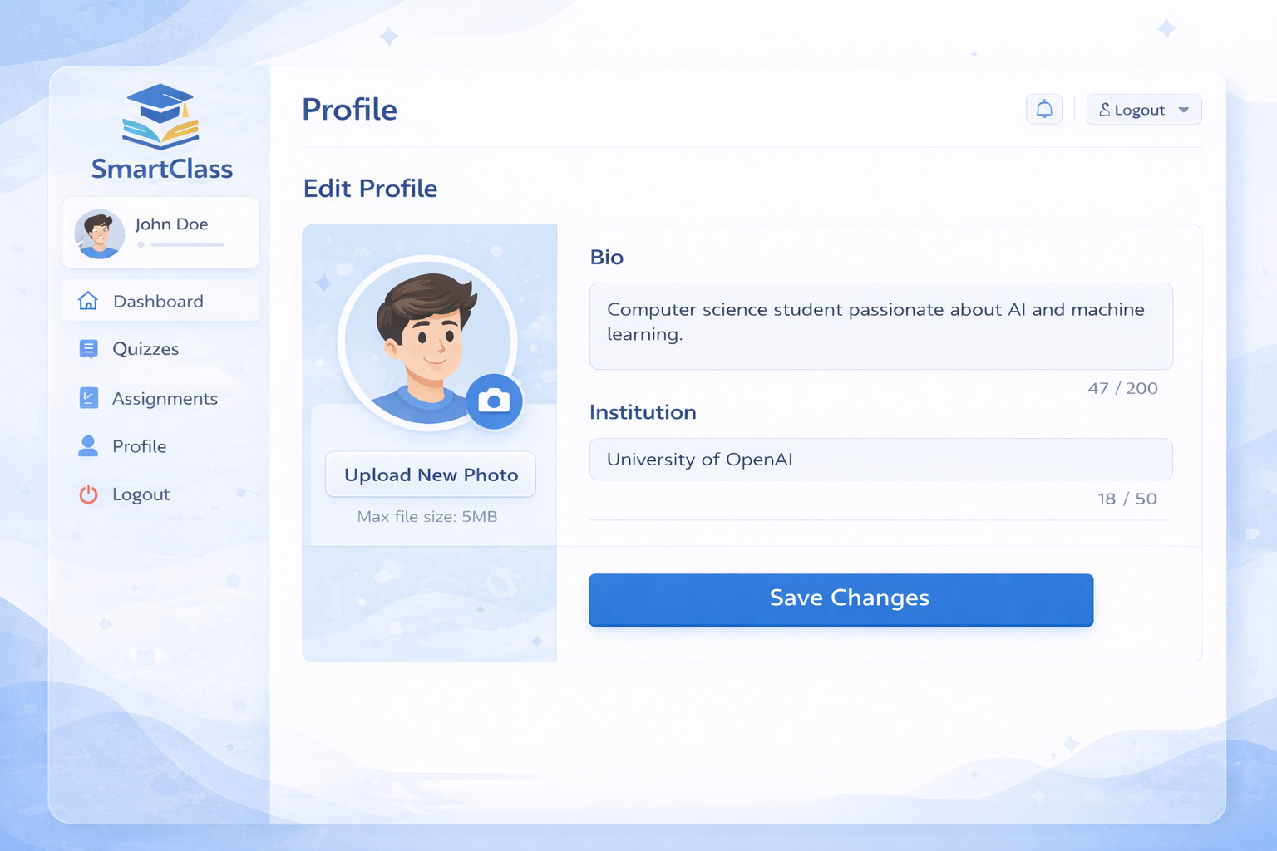

### **3.9 Quiz Screen**

**Purpose:**  
 Allows students to attempt quizzes.

**Controls:**

* Multiple Choice Options (Radio Buttons)
* Submit Button

**Input Constraints:**

* One option selectable per question

**Diagram:**

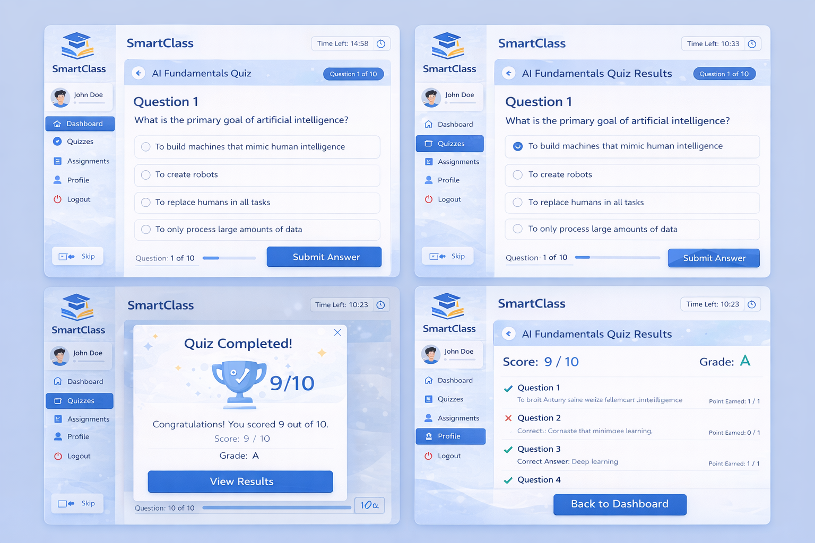

### **3.10 Assignment Screen**

**Purpose:**  
 Allows students to upload assignments.

**Controls:**

* File Upload Control
* Submit Button

**Input Constraints:**

* Allowed file formats
* File size limit

**Diagram:**

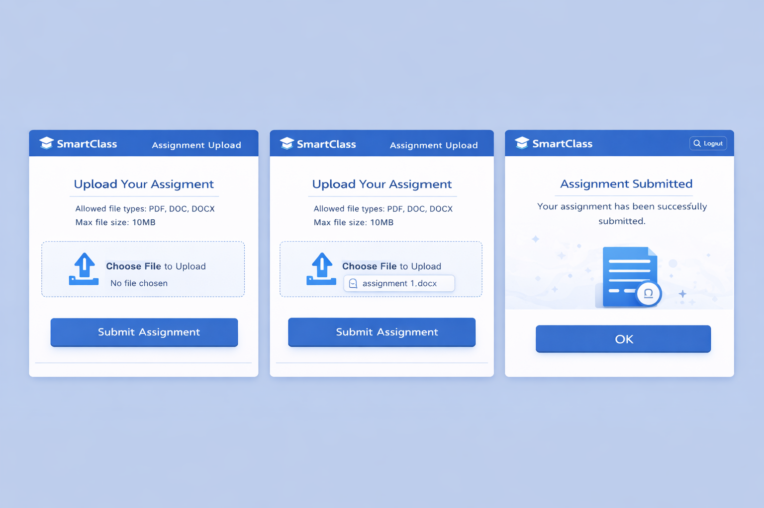

### **3.11 Result / Grades Screen**

**Purpose:**  
 Displays quiz and assignment results.

**Controls:**

* Read-only data view
* No input fields

**Diagram:**



## **3.12 Navigation Flow Diagram**

**Purpose:**

Shows how users navigate between different screens in the SmartClass application based on login status, user role, and actions performed on each screen.

**Controls:**

* Automatic redirection from Splash Screen
* Navigation links between screens
* Role-based redirection (Student / Teacher)
* Logout option

**Flow Description:**

* When the application starts, the user is taken to the **Splash Screen**
* If the user is opening the app for the first time, the system displays the **Onboarding Screens**, otherwise it moves to the **Login Screen**.
* From the **Login Screen**, users can:
  + Log in and move to their respective **Dashboard** (Student or Teacher).
  + Open the **Forgot Password Screen**.
* After successful login:
  + **Students** can navigate to Quiz, Assignment, Profile, and Result screens.
  + **Teachers** can navigate to Manage Quizzes, Manage Assignments, Profile, and Student Results.
* Clicking **Logout** from any dashboard redirects the user back to the

**Diagram**

